**Design Document-ASSIGNMENT-3**

**IMT2023013-AREEN PATIL**

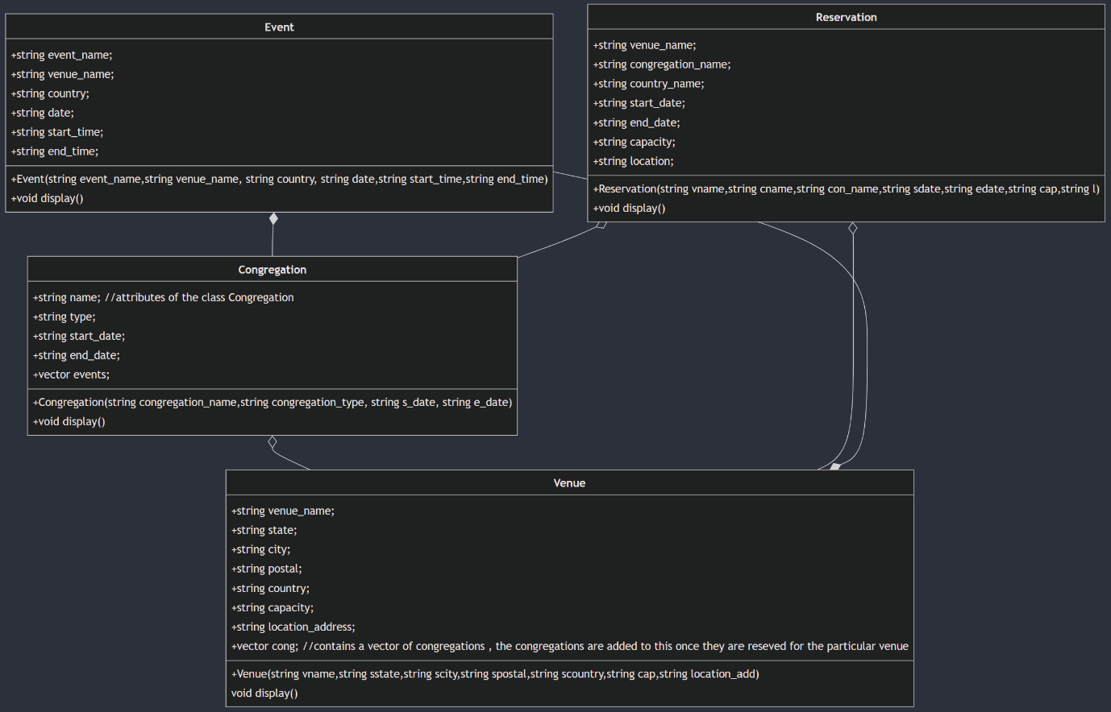

Classes:

Venue, Event, Congregation and Reservation

Relationship between the different classes: